Hi Sunny –

The third chart looks great! We’re good to go with that one and can move on to the next.

For this next chart, I would like to create another bar chart using the following specifications. I have created a new db table containing the data for this chart. It will present the daily average gain/loss that occurs in each quadrant, and, the daily average standard deviation of returns for each quadrant. The user will be able to toggle the legend to determine whether the chart is displaying either average PnL OR average standard deviation. Ideally, I’d like for the chart to be displaying only one of the sets of information at a time.

I have created a screenshot in MS Paint to try to illustrate what I’m hoping the final graph will look like:

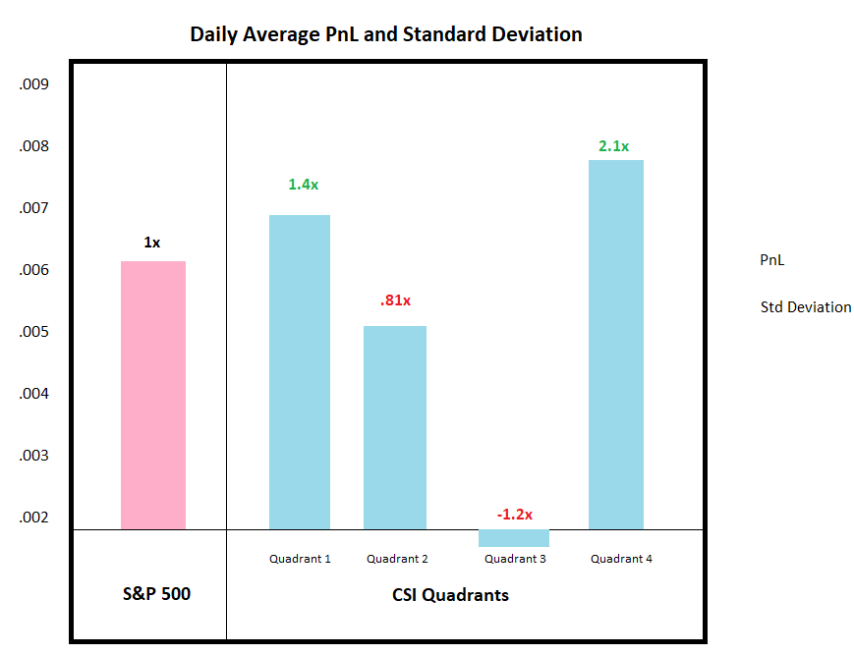

Features of the graph

1 – Values to be graphed:

**Part 1a) PnL values**

When the user has selected “PnL” in the legend, the information graphed from the table will be found in the following db columns:

'spy_mean', 'quadrant1_mean', 'quadrant2_mean', 'quadrant3_mean', 'quadrant4_mean'

The float values in these columns contain the literal values to be graphed. The legend on the y-axis should reflect the scale of these values.

*Additionally* - I’m hoping to have the graph annotated using values in the following columns:

'spy_mean_multi', 'quadrant1_mean_multi', 'quadrant2_mean_multi', 'quadrant3_mean_multi', 'quadrant4_mean_multi'

The word “multi” stands for multiplier. It means the amount greater than the average (the average being the value for SPY). I’m hoping to have the annotation above each bar signifying the amount greater than or less than the amount of SPY with certain rules:

If the amount is 1 == then the text should be black

If the amount is < 1 == then the text should be red

If the amount is > 1 == then the text should be green

An existing example of annotation can be found here: https://www.amcharts.com/demos/variance-indicators/

**Part 1b) Std Deviation values**

IF the user selects Std Deviation in the legend, the values for PnL should disappear and in their place should be the values for Standard Deviation. These values can be found in the following columns:

'spy_std', 'quadrant1_std', 'quadrant2_std', 'quadrant3_std', 'quadrant4_std'

Like the above, I’m hoping to have the bars annotated above each bar with multiplier values that can be found in the following columns in the db table:

'spy_std_multi', 'quadrant1_std_multi', 'quadrant2_std_multi', 'quadrant3_std_multi', 'quadrant4_std_multi'

Additionally, the same rules will apply here where if the value is 1 the text will be black, greater than 1 the text will be green, and less than 1 the text should be red.

2 – Sectioned off areas of the graph:

I would like to copy the x-axis label formatting of the following example chart: <https://www.amcharts.com/demos/grouped-and-sorted-columns/>

I have taken a screengrab and highlighted it in the image below:

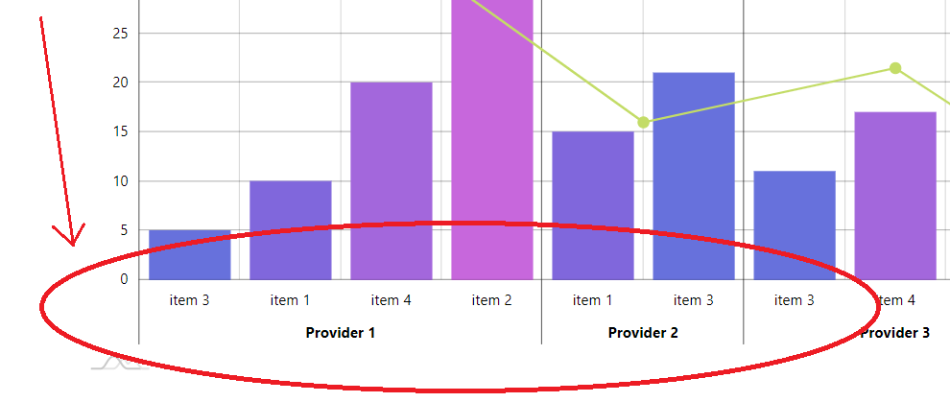

(I also incorporated this formatting in my own screenshot at the beginning of the document)

3 – Bar colors

Can all the CSI quadrant bars be the same color… and then the S&P 500 bar be a different color?

<https://www.amcharts.com/docs/v4/tutorials/column-labels-as-categories/>

<https://www.amcharts.com/docs/v4/tutorials/managing-width-and-spacing-of-column-series/>

<https://www.amcharts.com/demos/clustered-bar-chart/>